***Q:no:01: Write a code using***

1. ***Simple power function. ab***

***Code:***

#include<iostream>

using namespace std;

class power{

int a;

public:

power()

{

a=0;

}

int pwr(int b,int p)

{

a=b;

for(int i=1;i<p;i++)

{

b=b*a;

}

return b;

}

};

int main()

{

power p1;

int b,p;

cout<<"Enter base: ";

cin>>b;

cout<<"Enter power: ";

cin>>p;

int a=p1.pwr(b,p);

cout<<"Answer: "<<a<<endl;

}

***Output:***

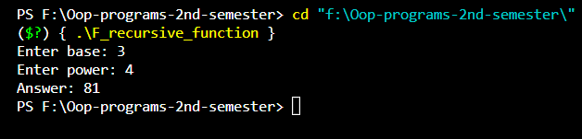

***Q:no:04: Write a code using***

1. ***power recursive function i.e ab=a*ab-1***

***Code:***

#include<iostream>

using namespace std;

class power{

int a;

public:

int pwr(int b,int p)

{

if(p==1)

return b;

else

return b*pwr(b,p-1);

}

};

int main()

{

power p1;

int b,p;

cout<<"Enter base: ";

cin>>b;

cout<<"Enter power: ";

cin>>p;

int a=p1.pwr(b,p);

cout<<"Answer: "<<a<<endl;

}

***Output:***

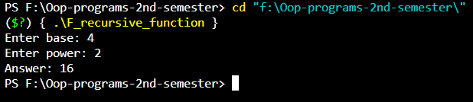

***Q:no:05: Write a code using***

1. ***Simple combination function v(n,k)=n!/k!(n-k)!***

***Code:***

#include<iostream>

using namespace std;

class comb{

int f;

public:

comb()

{

f=0;

}

int fact(int n)

{

f=1;

for(int i=1;i<=n;i++)

f=f*i;

return f;

}

};

int main()

{

comb c1;

int n,k;

cout<<"Enter value of n: ";

cin>>n;

cout<<"Enter value of k: ";

cin>>k;

int a=c1.fact(n);

int b=c1.fact(k);

int c=c1.fact(n-k);

int d=a/(b*c);

cout<<"Combination: "<<d<< endl;

}

***Output:***

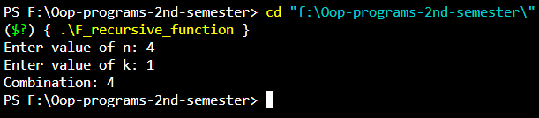

***Q:no:06: Write a code using***

1. ***Combination recursive function c(n,k)= $\left\{\begin{aligned}1, n=k, k=o \\ c\left(n-1, k-1\right)+c\left(n-1, k\right), otherwie\end{aligned}\right\}$.***

***Code:***

#include<iostream>

using namespace std;

class comb{

public:

int combn(int n,int k)

{

if(n==k || k==0)

return 1;

else

return (combn(n-1,k-1)+combn(n-1,k));

}

};

int main()

{

comb c;

int n;

cout<<"Enter n: ";

cin>>n;

int k;

cout<<"Enter k: ";

cin>>k;

int com=c.combn(n,k);

cout<<"COMBINATION: "<<com<<endl;

}

***Output:***

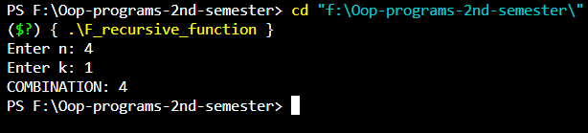

***Q:no:07: Write a code using***

1. ***Factorial recursive function.***

***Code:***

#include<iostream>

using namespace std;

int fact(int n)

{

if(n==1)

return 1;

else

return n*fact(n-1);

}

int main()

{

int num= fact(5);

cout<<"factorial of 5:"<<num<<endl;

}

***Output:***

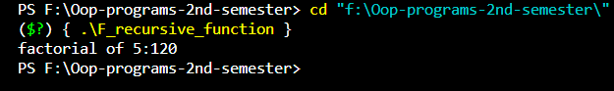

**OR**

#include<iostream>

using namespace std;

int pow(int a, int b)

{

if (b == 0)

return 1;

else

return a * pow(a, b - 1);

}

int fact(int a)

{

if (a == 1)

return 1;

else

return a * fact(a-1);

}

int cmb(int n, int k)

{

if (n == k || k == 0)

return 1;

else

return cmb(n - 1, k - 1) + cmb(n - 1, k);

}

int main()

{

int choice;

do {

cout << "\n\nEnter" << endl

<< "1. Factorial " << endl

<< "2. Power" << endl

<< "3. Combination by simplpe" << endl

<< "4. Combbination by recursive" << endl;

cin >> choice;

switch (choice)

{

case 1:

{

int a;

cout << "Enter no. ";

cin >> a;

cout << fact(a);

}

break;

case 2:

{

int a, b;

cout << "Enter base and power respectively" << endl;

cin >> a;

cin >> b;

cout << pow(a, b);

}

break;

case 3:

{

int n, k;

cout << "Enter values" << endl;

cin >> n;

cout << " C" << endl;

cout << " ";

cin >> k;

cout << fact(n) / (fact(k) * fact(n - k));

}

break;

case 4:

{

int a, b;

cout << "Enter values" << endl;

cin >> a >> b;

cout << cmb(a, b);

}

break;

}

} while (choice != 5);

}